**Duty Terminal Stops**

***Work-flow to Use Duty Terminal Stops***

Use **Load Template** to set up the preference. Only one instance of this preference may be used. Two templates are available, one of which is an extension of the other.

***Preference Overview***

This preference defines the way in which relief vehicles are used to transport drivers to and from duties.

There are several underlying items that need to be defined for this preference to be effective:

Stops at which a driver may start and end his duty



Stops at which a driver may start and finish a split break



Further it must be determined whether start and end stops be at the same depot or whether should they be defined in a list of specific start and end stops.

***Templates Available from Optibus***

*Table 1-1: Templates Summary*

|  |  |  |
| --- | --- | --- |
| **Template Name** | **Purpose** | **Reference** |
| Duty terminal stops | Sets up relief vehicle parameters. A relief vehicle may also be another fleet vehicle (as distinct from a taxi or any other third part shuttle transport). Using a fleet vehicle as a relief vehicle, is a deadhead. | **Duty terminal stops** |
| Relief Vehicles | This template differs from the previous one in not having the last field, **Use vehicles as relief vehicles**. | **Relief Vehicles** |

***Duty terminal stops***

**Purpose:**

Sets up relief vehicle parameters. A relief vehicle may also be another fleet vehicle (as dis- tinct from a taxi or any other third part shuttle transport). Using a fleet vehicle as a relief vehicle, is a deadhead.

**Prerequisites:**

You must set the driver terminal and split stop groups It is done in Expert Mode in consultation with Optibus Professional Servicesand requires at least one list of Stop Groups to be set in the **Stop Groups** preference. (You can use the latter preference to



create several named stop groups. For example you can create stop groups for "Start

Duty", "End Duty", "Start Split", "End Split" and so on.)

If you require start and end duty stops to be at the same depot, then enable Vehicle depot circularity in the **Depot Vehicle Allocation** preference



**Opening Dialog:**

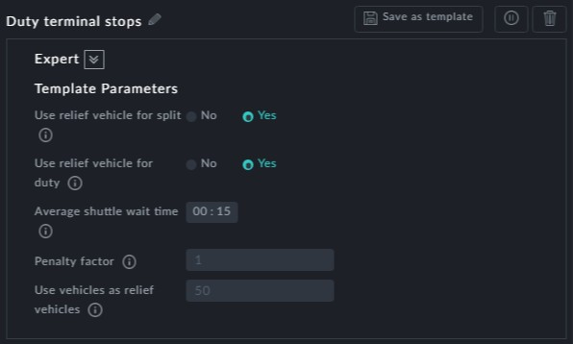

**Points to note:**

**Use relief vehicle for split**: Setting this to Yes means that a driver may travel as a pas- senger in a releif vehicle from the end point of the first duty piece to his split location or from the split location to the first stop of his second duty piece



**Use relief vehicle for duty**: Setting this to Yes means that a driver may travel as a passenger on a relief vehicle from his duty start point to the actual location of the vehicle for his duty or to his duty end point from where he left the vehicle



**Average shuttle wait time**: This is a fixed cost in work hours paid for each use of a shuttle vehicle



**Penalty factor**: This is a factor that multiplies the taxi relief vehicle's distance. It is a penalty for using ataxi.



**Use vehicles as relief vehicles**: This allows conversion of relief trips to deadheads. it does this by imposing a penalty. The higher the penalty, the greater the pereference



to use a deadhead as the means of a relief trip

There may be only one instance of this preference



***Relief Vehicles***

**Purpose:**

This template differs from the previous one in not having the last field, **Use vehicles as relief vehicles**.

**Prerequisites:** The same as the previous template

**Opening Dialog:**

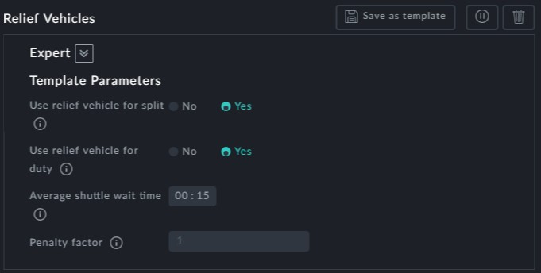

**Points to note:**

This version of the template does not allow conversion of the relief trip to a deadhead.